Business Template
sales

Contents
- Business Description
  - Business background
  - Problems because of poor data management
  - Benefits from implementing a Data Warehouse
  - DATASETS DESCRIPTION
  - GRAIN / DIM / FACT
- Business Layer 3N
- Business Layer Dimensional Model
- Logical Scheme
- Data Flow
- Fact Table Partitioning Strategy

1. Business Description
- Business background
The business represents a retail company that operates through two main sales channels: in-store (physical retail stores) and online e-commerce platforms. Customers can purchase products either by visiting physical stores or by placing orders through an online website.
The retail system manages a wide range of products including clothing, books, and electronics, and serves customers across multiple cities in the United States. Each transaction records essential business information such as product details, customer information, payment method, and transaction value.
The business aims to analyze sales performance, customer behavior, product demand, and profitability across both retail channels in order to optimize decision-making and improve operational efficiency.

  - Problems because of poor data management
Without a centralized data management system, the business faces several challenges. Data from in-store and online systems is stored separately, making it difficult to combine and analyze performance across channels.
This leads to issues such as:
- Inability to compare online and offline sales performance
- Difficulty in identifying profitable products and customers
- Lack of consistent reporting across systems
- Data duplication and inconsistency in transaction records
- Limited ability to perform historical trend analysis
As a result, business decisions are often based on incomplete or fragmented information, reducing operational efficiency and profitability.

  - Benefits from implementing a Data Warehouse
Implementing a Data Warehouse provides a unified and structured view of all business data by integrating multiple operational systems into a single analytical platform.
The key benefits include:
- Centralized and consistent data storage from both retail and online channels
- Improved reporting and analytics capabilities
- Ability to analyze customer behavior across multiple channels
- Enhanced product performance tracking and profitability analysis
- Support for time-based trend analysis and forecasting
- Better decision-making through OLAP operations such as drill-down and roll-up
Additionally, a data warehouse enables advanced segmentation of customers, products, and regions, allowing the business to improve marketing strategies and operational planning.

  - DATASETS DESCRIPTION
I used Retail Analysis on Large Dataset: https://www.kaggle.com/datasets/fahadrehman07/retail-transaction-dataset I got data from here, duplicated it added more data because it was not enough in the beginning, changed dates and I changed adresses and put in-store and online options.

The project uses two different but related datasets representing two separate source systems: Retail Store Sales Data and Online E-commerce Sales Data.
Both datasets are derived from a retail domain but differ in structure, attributes, and business processes.

First Dataset — Retail (In-Store Sales System)
The first dataset represents in-store transactions collected from physical retail stores located across different cities in the United States. It contains transaction-level data captured at the point of sale (POS) system.
This dataset includes:
- Customer information (CustomerID, segment, type, city, loyalty score)
- Product information (ProductID, category, brand, price)
- Transaction details (TransactionID, date, quantity, sales value, cost, profit)
- Payment information (payment method, status, risk score)
- Store information (store location, region, store type)
This dataset reflects traditional physical shopping behavior where customers purchase items directly from stores.

Second Dataset — Online (E-commerce Sales System)
The second dataset represents online retail transactions generated through an e-commerce platform. Customers place orders via web or mobile devices, and products are delivered through shipping or pickup methods.
This dataset includes:
- Customer information (CustomerID, demographics, city, segment)
- Product information (ProductID, category, brand, price)
- Order information (TransactionID, date, quantity, sales value, discount, profit)
- Payment information (payment method, status, channel, risk score)
- Delivery information (shipping cost, delivery type, delivery status, fulfillment time)

Dataset Separation Logic (IMPORTANT REQUIREMENT)
The second dataset is generated from the first dataset using a business-based transformation approach. While both datasets share similar product and customer structures, they differ in:
- Transaction channel (Retail vs Online)
- Payment methods (Cash/Card vs Card/PayPal/ApplePay)
- Presence of delivery attributes (only Online system)
- Transaction ID structure (separate ID ranges)
- Additional cost components (shipping cost in Online system)
- Operational behavior (store-based vs digital ordering)
This separation ensures that the datasets represent two realistic and independent source systems while maintaining analytical consistency for Data Warehouse integration.
- Hierarchy Requirement
The datasets include a well-structured hierarchy system that supports OLAP analysis:
- Time Hierarchy: Year → Month → Day (TransactionDate)
- Geography Hierarchy: Country → Region → City → Store
- Product Hierarchy: Category → Subcategory → Product
- Customer Hierarchy: Segment → Type → Individual Customer
These hierarchies allow the system to perform drill-down and roll-up analysis for business intelligence reporting.

  - GRAIN / DIM / FACT

Grain Definition
The grain of the data warehouse is defined as:
One row in the fact table represents a single product transaction (purchase event) made by a customer in either the retail or online system.
Each record contains transaction-level details including quantity, price, cost, discount, and profit.

Dimensions
The data warehouse includes the following dimension tables:

Customer Dimension
Describes customer attributes such as segment, type, age group, and city.

Product Dimension
Contains product details including category, subcategory, brand, and price.

Date Dimension
Provides time-based attributes such as year, month, and day.

Payment Dimension
Includes payment method, status, and risk score.

Store Dimension
Describes physical store or online channel information.

Delivery Dimension (Online only)
Includes shipping method, delivery status, and fulfillment time.

Fact Table
The central Fact_Sales table contains measurable business events.

Measures include:
- Quantity
- SalesValue
- Discount
- CostPrice
- TotalCost
- Profit
- ShippingCost (Online only)

Keys:
- TransactionID
- CustomerID
- ProductID
- StoreID
- TransactionDate
- PaymentMethod

Final Summary
The proposed data warehouse follows a star schema design that integrates retail and online transactional systems into a unified analytical model. It supports multi-dimensional analysis across customer behavior, product performance, and sales trends. The inclusion of hierarchies enables efficient OLAP operations, while the separation of source systems ensures data variety and business realism.

- Business Layer 3N

Design Process

Step 1: Analyze Source Systems
Two source systems were selected for the project: Retail Sales and Online Sales. Both datasets contain similar business information related to customers, products, transactions, payments, stores, deliveries, and dates.
The first step was to analyze both datasets and identify common business entities. Since the Business Layer integrates data from multiple source systems, entities that appear in both datasets are represented only once in the 3NF model.

Step 2: Identify Business Entities
Based on the analysis of the source systems, the following business entities were identified:
- Customer
- Product
- Store
- Payment
- Delivery
- Date
- Transaction
These entities represent the core business objects required to support analytical reporting and future dimensional modeling.

Step 3: Integrate Common Entities
To avoid data duplication and support enterprise-wide reporting, common entities from the Retail and Online datasets were consolidated into single business entities.
For example, customer information from both source systems is stored in one CE_CUSTOMER table, while product information from both sources is stored in one CE_PRODUCT table.
This approach ensures data consistency and supports the integration requirements of the Business Layer.

Step 4: Define Surrogate Keys and Natural Keys
Each entity includes a surrogate key (SK) that serves as the primary key of the table. Surrogate keys are generated by the data warehouse and provide unique identification of records across multiple source systems.
Each entity also contains one or more natural key (NK) attributes originating from the source systems. Natural keys are used during ETL processing to identify business entities and manage data integration.

Step 5: Implement Source Triplet
To provide full data lineage and source traceability, the Source Triplet was added to all business entities:
- SOURCE_SYSTEM
- SOURCE_ENTITY
- SOURCE_ID
These attributes allow identification of the original source system, source entity, and source record from which the business layer data was loaded.

Step 6: Implement Slowly Changing Dimension Type 2
The Customer entity was selected for Slowly Changing Dimension Type 2 (SCD2) implementation because customer attributes may change over time.
Examples of changing customer attributes include:
- Customer Segment
- Customer Type
- Customer City
- Loyalty Score
- Age Group
To preserve historical changes, the CE_CUSTOMER entity includes the following SCD2 attributes:
- START_DT
- END_DT
- IS_ACTIVE
Whenever a customer attribute changes, a new record is created with a new surrogate key while preserving previous versions of the customer record. This approach enables historical analysis of customer behavior and segmentation.

Step 7: Add Audit Columns
Following the naming conventions, audit columns were added to all entities:
- INSERT_DT
- UPDATE_DT
These attributes support ETL monitoring and data maintenance activities.

Step 8: Define Relationships
The CE_TRANSACTION entity represents the transaction grain and acts as the central business entity in the model.
Foreign keys were created to connect transactions with the related business entities:
- CUSTOMER_SK
- PRODUCT_SK
- STORE_SK
- PAYMENT_SK
- DELIVERY_SK
- DATE_SK
This structure ensures referential integrity and provides a unified view of business transactions across both source systems.

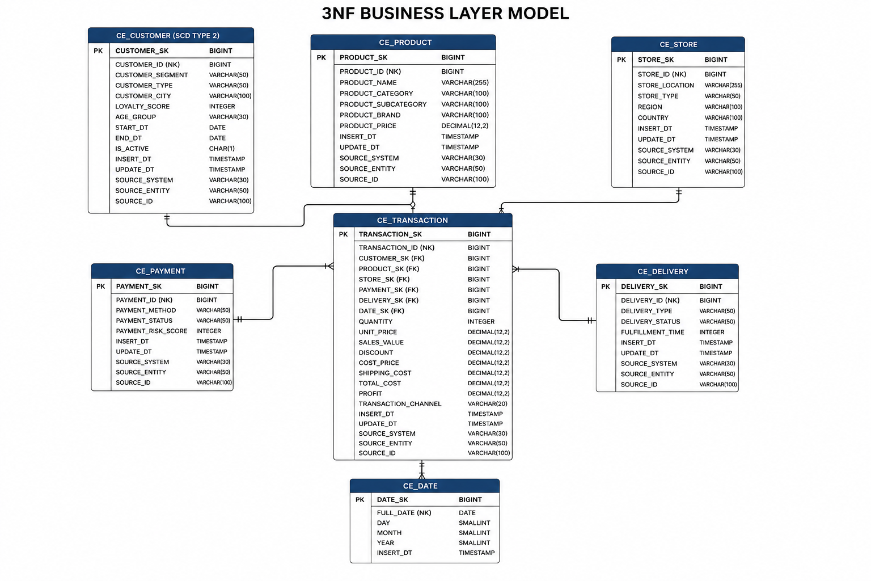
Figure 2.1. Business Layer 3NF Model
The Business Layer 3NF model integrates data from the Retail and Online source systems into a unified enterprise data model. Common business entities such as Customer, Product, Store, Payment, Delivery, and Date are represented by a single table regardless of their source system. Each entity contains a surrogate key for warehouse integration, a natural key for business identification, and a source triplet (SOURCE_SYSTEM, SOURCE_ENTITY, SOURCE_ID) to ensure data lineage and traceability. The CE_TRANSACTION entity acts as the central transactional table and maintains relationships with all business entities through foreign keys. The CE_CUSTOMER entity is implemented as a Slowly Changing Dimension Type 2 (SCD2) to preserve historical customer attribute changes over time.

- Business Layer Dimensional Model
The Business Layer Dimensional Model (schema BL_DM) converts the BL_3NF entities built in Chapter 2 into a star schema optimized for reporting and OLAP-style analysis. Each CE_ entity from the normalized layer is transformed into a dimension or fact table, denormalized, and enriched with the technical columns required by the project naming convention (surrogate keys, source triplet, audit dates, and SCD2 attributes where applicable).

Design Process

Step 1: Confirm the Grain
The business process being modeled is a retail sales transaction that can occur either in a physical store or through the online channel. The most detailed level of data available in the source systems is a single product line within a transaction, so this is the level chosen for the fact table.
Grain statement of FCT_TRANSACTIONS_DD:
One row represents one product sold within one transaction, linked to one customer, one store, one payment, one delivery method (where applicable) and one calendar date.
This grain was kept unchanged from the conceptual grain defined in Chapter 1 (section GRAIN / DIM / FACT) — it satisfies the transaction-grain pattern described in the Dimension & Fact Table Techniques courseware: the fact table stores an instantaneous measurement event and is true to the grain, which keeps the design simple to extend and safe to aggregate later.

Step 2: Convert 3NF Entities into Star-Schema Dimensions
Each core entity (CE_) table from the BL_3NF layer becomes one dimension table in BL_DM. Following Kimball's guidance that presentation-layer dimensions should be physically flattened, the small hierarchies that exist in the source data (for example Product Category → Subcategory, or Store Region → Country) are kept as denormalized descriptive columns directly inside the dimension row, rather than split into a snowflake of separate lookup tables.
BL_3NF entity | BL_DM table
CE_CUSTOMER (SCD Type 2) | DIM_CUSTOMERS_SCD
CE_PRODUCT | DIM_PRODUCTS
CE_STORE | DIM_STORES
CE_PAYMENT | DIM_PAYMENTS
CE_DELIVERY | DIM_DELIVERIES
CE_DATE | DIM_DATES (rebuilt independently, see Step 5)
CE_TRANSACTION | FCT_TRANSACTIONS_DD

Step 3: Apply DM-Layer Naming Conventions
Per Naming_Conventions.docx, every dimension table is renamed with the DIM_ prefix in plural form, and the fact table with the FCT_ prefix plus a grain suffix (_DD, since the fact table carries the finest, transaction-level grain). Every table also receives the required technical columns:
- <NAME>_SURR_ID — surrogate primary key, generated by a sequence (never SERIAL).
- <NAME>_SRC_ID — the natural key inherited from the source system.
- SOURCE_SYSTEM / SOURCE_ENTITY — the source triplet, completing lineage together with <NAME>_SRC_ID.
- INSERT_DT / UPDATE_DT — audit columns recording row creation and last change.
The rough draft schema originally sketched in Chapter 1 (FACT_TRANSACTIONS, DIM_CUSTOMER, DIM_PRODUCT, DIM_STORE, DIM_PAYMENT, DIM_DELIVERY, DIM_DATE) used business-friendly key names such as CustomerKey/CustomerID. That draft has been superseded by the fully compliant table definitions below; Chapter 1 now keeps only the conceptual grain/dimension/fact overview.

Step 4: Carry Forward SCD Type 2 on the Customer Dimension
Customer was selected for Slowly Changing Dimension Type 2 in Chapter 2, so DIM_CUSTOMERS_SCD keeps the START_DT, END_DT and IS_ACTIVE columns from CE_CUSTOMER. Whenever a tracked attribute changes (segment, type, city, loyalty score, age group), a new row is inserted with a new CUSTOMER_SURR_ID; the previous row is expired (END_DT populated, IS_ACTIVE = 'N'). As required by the naming convention, the foreign key from FCT_TRANSACTIONS_DD to DIM_CUSTOMERS_SCD is logical only — no database FK constraint is created against an SCD2 dimension.

Step 5: Design DIM_DATES Independently
Unlike the other five dimensions, DIM_DATES is not sourced from BL_3NF. Per the task requirement, it is created once with its own DDL script and populated for the full calendar range the project needs (2015-01-01 to 2030-12-31), instead of being refreshed on every ETL run. The full CREATE TABLE and population script is provided as a separate deliverable, DIM_DATES_create_and_populate.sql (see excerpt in the 'DIM_DATES Population Script' section below).

Step 6: Define the Fact Table Keys, Degenerate Dimension and Measures
FCT_TRANSACTIONS_DD carries one foreign surrogate key per dimension (CUSTOMER_SURR_ID, PRODUCT_SURR_ID, STORE_SURR_ID, PAYMENT_SURR_ID, DELIVERY_SURR_ID, DATE_SURR_ID) plus the obligatory EVENT_DT column that stores the date of the measurement event. The original TRANSACTION_ID from the source systems does not warrant its own dimension table — it has no descriptive attributes beyond the identifier itself — so, following the degenerate-dimension pattern from the courseware, it is kept directly in the fact table as TRANSACTION_SRC_ID. All measure columns are prefixed FCT_ and suffixed with a unit (_NUM, _AMT), matching the FCT_<NAME>_<UNIT> convention. Retail (in-store) transactions have no delivery information, so they are linked to the default 'n.a.' row (DELIVERY_SURR_ID = -1) in DIM_DELIVERIES rather than left NULL.
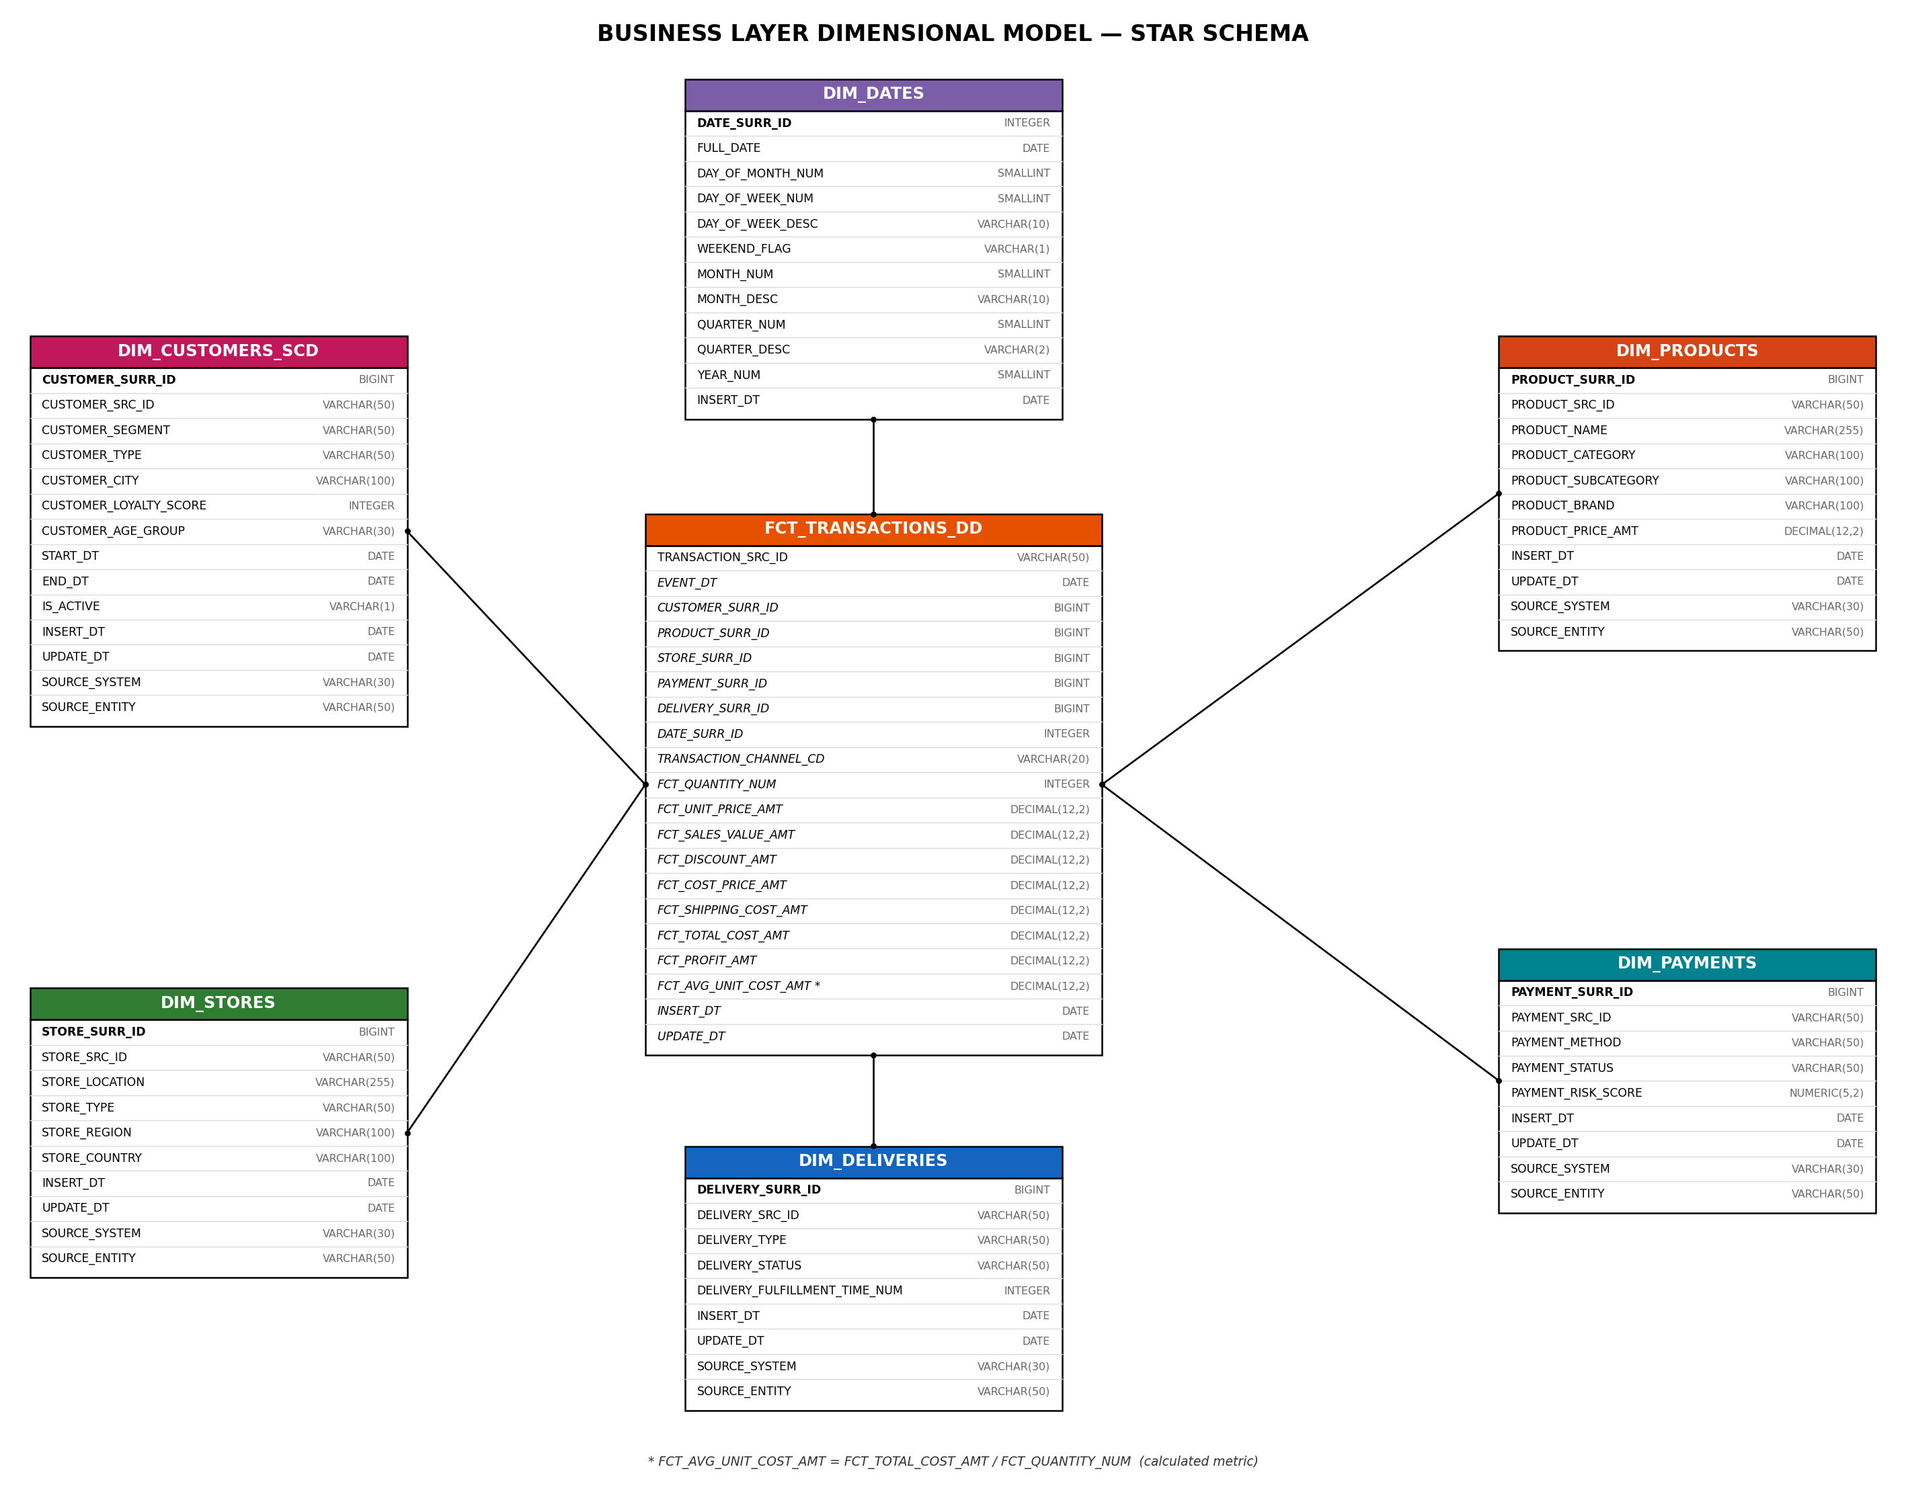
Figure 3.1. Business Layer Dimensional Model (Star Schema)
The Business Layer Dimensional Model organizes the retail and online sales data as a classic star schema: FCT_TRANSACTIONS_DD sits at the center and connects to six denormalized dimensions. DIM_CUSTOMERS_SCD is the only Type 2 dimension, preserving the full history of customer attribute changes; DIM_PRODUCTS, DIM_STORES, DIM_PAYMENTS and DIM_DELIVERIES are Type 0/1 dimensions maintained as the latest known values; and DIM_DATES is a standalone, pre-populated calendar dimension. This structure allows end users to slice sales, profit and cost measures by customer, product, store, payment, delivery and time with single-join queries, supporting the drill-down/roll-up scenarios described in Chapter 1.

Dimension and Fact Table Definitions
DIM_CUSTOMERS_SCD
Column name | Description | Data Type
CUSTOMER_SURR_ID | Surrogate primary key (sequence-generated) | BIGINT
CUSTOMER_SRC_ID | Natural key inherited from CE_CUSTOMER (CUSTOMER_ID) | VARCHAR(50)
CUSTOMER_SEGMENT | Customer segmentation category | VARCHAR(50)
CUSTOMER_TYPE | Type of customer | VARCHAR(50)
CUSTOMER_CITY | Customer's city | VARCHAR(100)
CUSTOMER_LOYALTY_SCORE | Customer loyalty score | INTEGER
CUSTOMER_AGE_GROUP | Customer age category | VARCHAR(30)
START_DT | Start date of the period this row's values were active (SCD2) | DATE
END_DT | End date of the period this row's values were active (SCD2) | DATE
IS_ACTIVE | Current-row indicator: Y = current, N = expired (SCD2) | VARCHAR(1)
INSERT_DT | Date the row was created | DATE
UPDATE_DT | Date the row was last modified | DATE
SOURCE_SYSTEM | Source system this row was loaded from | VARCHAR(30)
SOURCE_ENTITY | Source entity/table this row was loaded from | VARCHAR(50)
DIM_PRODUCTS
Column name | Description | Data Type
PRODUCT_SURR_ID | Surrogate primary key (sequence-generated) | BIGINT
PRODUCT_SRC_ID | Natural key inherited from CE_PRODUCT (PRODUCT_ID) | VARCHAR(50)
PRODUCT_NAME | Name of the product | VARCHAR(255)
PRODUCT_CATEGORY | Product category (denormalized hierarchy attribute) | VARCHAR(100)
PRODUCT_SUBCATEGORY | Product subcategory (denormalized hierarchy attribute) | VARCHAR(100)
PRODUCT_BRAND | Product brand name | VARCHAR(100)
PRODUCT_PRICE_AMT | Standard catalog price of the product | DECIMAL(12,2)
INSERT_DT | Date the row was created | DATE
UPDATE_DT | Date the row was last modified | DATE
SOURCE_SYSTEM | Source system this row was loaded from | VARCHAR(30)
SOURCE_ENTITY | Source entity/table this row was loaded from | VARCHAR(50)
DIM_STORES
Column name | Description | Data Type
STORE_SURR_ID | Surrogate primary key (sequence-generated) | BIGINT
STORE_SRC_ID | Natural key inherited from CE_STORE (STORE_ID) | VARCHAR(50)
STORE_LOCATION | Physical location of the store (or 'Online' for the e-commerce channel) | VARCHAR(255)
STORE_TYPE | Type of store (Physical / Online) | VARCHAR(50)
STORE_REGION | Region where the store operates (denormalized hierarchy attribute) | VARCHAR(100)
STORE_COUNTRY | Country where the store operates (denormalized hierarchy attribute) | VARCHAR(100)
INSERT_DT | Date the row was created | DATE
UPDATE_DT | Date the row was last modified | DATE
SOURCE_SYSTEM | Source system this row was loaded from | VARCHAR(30)
SOURCE_ENTITY | Source entity/table this row was loaded from | VARCHAR(50)
DIM_PAYMENTS
Column name | Description | Data Type
PAYMENT_SURR_ID | Surrogate primary key (sequence-generated) | BIGINT
PAYMENT_SRC_ID | Natural key inherited from CE_PAYMENT (PAYMENT_ID) | VARCHAR(50)
PAYMENT_METHOD | Method used for payment (Cash, Card, PayPal, ApplePay, ...) | VARCHAR(50)
PAYMENT_STATUS | Status of the payment (Success, Failed, Pending, ...) | VARCHAR(50)
PAYMENT_RISK_SCORE | Risk score assigned to the payment | NUMERIC(5,2)
INSERT_DT | Date the row was created | DATE
UPDATE_DT | Date the row was last modified | DATE
SOURCE_SYSTEM | Source system this row was loaded from | VARCHAR(30)
SOURCE_ENTITY | Source entity/table this row was loaded from | VARCHAR(50)
DIM_DELIVERIES
Column name | Description | Data Type
DELIVERY_SURR_ID | Surrogate primary key (sequence-generated). -1 = 'n.a.' default row for retail transactions | BIGINT
DELIVERY_SRC_ID | Natural key inherited from CE_DELIVERY (DELIVERY_ID) | VARCHAR(50)
DELIVERY_TYPE | Type of delivery service (Shipping, Pickup, n.a.) | VARCHAR(50)
DELIVERY_STATUS | Status of the delivery (Delivered, In Transit, n.a.) | VARCHAR(50)
DELIVERY_FULFILLMENT_TIME_NUM | Delivery duration / lead time in days | INTEGER
INSERT_DT | Date the row was created | DATE
UPDATE_DT | Date the row was last modified | DATE
SOURCE_SYSTEM | Source system this row was loaded from | VARCHAR(30)
SOURCE_ENTITY | Source entity/table this row was loaded from | VARCHAR(50)
DIM_DATES
Column name | Description | Data Type
DATE_SURR_ID | Surrogate primary key, format YYYYMMDD. -1 = 'n.a.' default row | INTEGER
FULL_DATE | Calendar date value | DATE
DAY_OF_MONTH_NUM | Day number within the month (1-31) | SMALLINT
DAY_OF_WEEK_NUM | ISO day number within the week (1=Mon ... 7=Sun) | SMALLINT
DAY_OF_WEEK_DESC | Short day-of-week name (Mon, Tue, ...) | VARCHAR(10)
WEEKEND_FLAG | Y if Saturday/Sunday, else N | VARCHAR(1)
MONTH_NUM | Month number within the year (1-12) | SMALLINT
MONTH_DESC | Short month name (Jan, Feb, ...) | VARCHAR(10)
QUARTER_NUM | Quarter number within the year (1-4) | SMALLINT
QUARTER_DESC | Quarter label (Q1-Q4) | VARCHAR(2)
YEAR_NUM | Calendar year | SMALLINT
INSERT_DT | Date the row was created (one-time load) | DATE
FCT_TRANSACTIONS_DD
Column name | Description | Data Type
TRANSACTION_SRC_ID | Degenerate dimension: original transaction/line identifier from the source system | VARCHAR(50)
EVENT_DT | Date of the measurement event (transaction date) | DATE
CUSTOMER_SURR_ID | FK to DIM_CUSTOMERS_SCD (logical only, SCD2 dimension) | BIGINT
PRODUCT_SURR_ID | FK to DIM_PRODUCTS | BIGINT
STORE_SURR_ID | FK to DIM_STORES | BIGINT
PAYMENT_SURR_ID | FK to DIM_PAYMENTS | BIGINT
DELIVERY_SURR_ID | FK to DIM_DELIVERIES (-1 for retail/in-store transactions) | BIGINT
DATE_SURR_ID | FK to DIM_DATES | INTEGER
TRANSACTION_CHANNEL_CD | Channel through which the transaction occurred (Online / Retail) | VARCHAR(20)
FCT_QUANTITY_NUM | Number of units sold | INTEGER
FCT_UNIT_PRICE_AMT | Selling price per unit | DECIMAL(12,2)
FCT_SALES_VALUE_AMT | Total sales amount before deductions | DECIMAL(12,2)
FCT_DISCOUNT_AMT | Discount applied to the transaction line | DECIMAL(12,2)
FCT_COST_PRICE_AMT | Cost of goods sold | DECIMAL(12,2)
FCT_SHIPPING_COST_AMT | Cost of shipping the product (Online channel only, 0 for Retail) | DECIMAL(12,2)
FCT_TOTAL_COST_AMT | Total transaction cost (cost of goods + shipping) | DECIMAL(12,2)
FCT_PROFIT_AMT | Profit generated from the transaction line | DECIMAL(12,2)
FCT_AVG_UNIT_COST_AMT | Calculated metric: average cost per unit sold — see Metrics Description | DECIMAL(12,2)
INSERT_DT | Date the row was created | DATE
UPDATE_DT | Date the row was last modified | DATE

DIM_DATES Population Script
DIM_DATES is created and populated by a standalone script, DIM_DATES_create_and_populate.sql, run once at warehouse setup time (not as part of the recurring ETL load). The script creates the table, inserts the obligatory -1 'n.a.' default row, then generates one row per calendar day between 2015-01-01 and 2030-12-31 using PostgreSQL's generate_series function. Key excerpt:
CREATE TABLE bl_dm.dim_dates (
date_surr_id INTEGER NOT NULL,
full_date DATE NOT NULL,
day_of_month_num SMALLINT NOT NULL,
day_of_week_num SMALLINT NOT NULL,
day_of_week_desc VARCHAR(10) NOT NULL,
weekend_flag VARCHAR(1) NOT NULL,
month_num SMALLINT NOT NULL,
month_desc VARCHAR(10) NOT NULL,
quarter_num SMALLINT NOT NULL,
quarter_desc VARCHAR(2) NOT NULL,
year_num SMALLINT NOT NULL,
insert_dt DATE NOT NULL DEFAULT CURRENT_DATE,
CONSTRAINT pk_dim_dates PRIMARY KEY (date_surr_id)
);
INSERT INTO bl_dm.dim_dates (...)
SELECT (EXTRACT(YEAR FROM d)*10000 + EXTRACT(MONTH FROM d)*100 + EXTRACT(DAY FROM d))::INT,
d::DATE, ...
FROM generate_series('2015-01-01'::DATE, '2030-12-31'::DATE, INTERVAL '1 day') AS d;
The full script is provided as a separate deliverable file.

Metrics Description
All measures in FCT_TRANSACTIONS_DD are additive across every dimension except FCT_AVG_UNIT_COST_AMT, which is semi-additive (it must be re-derived after aggregation, not simply summed).
Base Measures (FCT_TRANSACTIONS_DD)
Column name | Description | Data Type
FCT_QUANTITY_NUM | Number of units of the product sold in the transaction line | Sourced directly from CE_TRANSACTION
FCT_UNIT_PRICE_AMT | Selling price of a single unit | Sourced directly from CE_TRANSACTION
FCT_SALES_VALUE_AMT | Total sales amount before discount = FCT_UNIT_PRICE_AMT × FCT_QUANTITY_NUM | Sourced directly from CE_TRANSACTION
FCT_DISCOUNT_AMT | Discount amount applied to the transaction line | Sourced directly from CE_TRANSACTION
FCT_COST_PRICE_AMT | Cost of goods sold for the line | Sourced directly from CE_TRANSACTION
FCT_SHIPPING_COST_AMT | Shipping cost (Online channel only; 0 for Retail) | Sourced directly from CE_TRANSACTION
FCT_TOTAL_COST_AMT | Total cost of the line = FCT_COST_PRICE_AMT + FCT_SHIPPING_COST_AMT | Sourced directly from CE_TRANSACTION
FCT_PROFIT_AMT | Profit generated by the line = FCT_SALES_VALUE_AMT − FCT_DISCOUNT_AMT − FCT_TOTAL_COST_AMT | Sourced directly from CE_TRANSACTION
Calculated Metric
FCT_AVG_UNIT_COST_AMT — Average Unit Cost — is the new metric added for this task. It is derived, not sourced, and is calculated during the ETL load of the fact table as:
FCT_AVG_UNIT_COST_AMT = FCT_TOTAL_COST_AMT / FCT_QUANTITY_NUM
This combines two existing base metrics (total cost and quantity) into a single per-unit cost figure. It lets analysts compare the true landed cost of a unit across products, stores and channels — e.g. verifying whether the online channel's added shipping cost measurably raises the effective per-unit cost compared with the retail channel — without needing to recompute the ratio in every report or BI tool.
- Logical Scheme
- Data Flow
- Fact Table Partitioning Strategy

